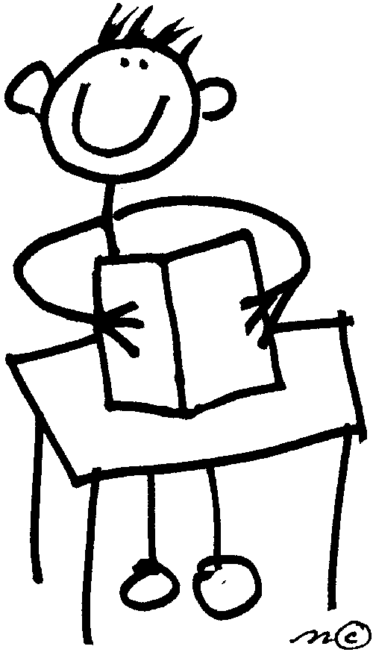

**Student Responsibilities**

* Be aware of assignments and to seek further explanation if needed.
* Record assignments in agenda.
* Organize his/her time to work on assignments.
* Turn in assignments on time.
* Work reflects high standards regarding effort and completeness.

**The Purpose of Homework**

Homework is one of the many learning activities in which students engage; its purposes are to:

* Develop initiative, responsibility, self-direction, and organizational skills
* Extend learning and/or provide practice in applying concepts initially presented in the classroom.
* Provide opportunities for independent work and/or study.
* Strengthen concept attainment, skill development and reinforcement.

**Matthews Elementary School**

**Homework Policy**

**Parent Responsibilities**

While the students should assume the major responsibility for completing homework assignments, parents are encouraged to take an active interest in the student’s homework by doing the following:

* Provide a study area that is quiet, comfortable, and free from major disturbances.
* Provide a definite time for study or other home activities.
* Make available resource materials, such as reference books, magazines, newspaper, dictionary, and/or the public library.
* Monitor the child’s daily and/or weekly assignment sheets/agendas and long-range assignments.
* Encourage the child to complete homework on their own as much as possible and assist only as needed.

**Reading Requirement**

It is the expectation that all students will read on a daily basis. This will be done in *conjunction with* homework assigned by the child’s classroom teacher(s).

**Kindergarten**—20 minutes per night

**Grade 1**—20 minutes per night

**Grade 2**—20 minutes per night

**Grade 3**—30 minutes per night

**Grade 4**—30 minutes per night

**Grade 5**—30 minutes per night

[](http://benlib.files.wordpress.com/2011/06/parrot-with-read.jpg)

**Time Allotments**

**Kindergarten**—up to 10 minutes per night

**Grade 1**—up to 10 minutes per night*

**Grade 2**—up to 20 minutes per night*

**Grade 3**—up to 30 minutes per night*

**Grade 4**—up to 40 minutes per night*

**Grade 5**—up to 50 minutes per night*

*To include several subject areas if applicable*

These times are appropriate. Individual student’s pace may need to be taken into consideration. We ask that problems or concerns be communicated directly to the classroom teacher.

**Guidelines &**

**Teacher Responsibilities**

* No assignments will be given that has not been clearly explained in the classroom.
* Students will fully understand when the assignment is due.
* Homework will be checked for effort and completion. Homework will be included as a learning skill and calculated into the student’s report card in grades 3-5. *Please reference Matthews Elementary Grading Policy.*
* Teachers will communicate to parents about missing or incomplete assignments as needed.
* Homework will not be assigned over holiday breaks and/or designated religious holidays when students are absent because of religious observances.

**K-5 Grading**

**Important Highlights**

Graded assignments will be aligned with content standards specific to your child’s grade level.

Students will not be provided with extra credit for bringing in canned goods, classroom materials, etc.

Students will be provided with opportunities for reteaching or tutorials in order to demonstrate “mastery” on a failed formal assessment.

*The retest grade will be replaced with the original grade.*



**Late/Make-Up Work**

**Grades K-5**

ALL students will be allowed to make-up the work missed.

Arrangements must be made within five (5) school days of the student’s return to school.

ALL homework and other assignments will be accepted, even when turned in late.

Credit will be awarded based on the following:

* If present in class on the due date, student may be given less credit

***5points per day—lowest grade of 50%***

* If not present in class on the due date because of an *excused* absence, full credit will be given

***Number of days absent = number of days allowed to make up work***

* If not present in class on the due date because of an *unexcused* absence, the work maybe give less credit

***Number of days absent = number of days allowed to make up work***

**Matthews Elementary School Grading Policy**



**Matthews Elementary**

**Grading Guiding Principles**

**K-5**

The purpose of collecting grades is to assess the students’ mastery of content, skills, and to assess learning.

* Grades will be based on academics only.
* Grades will not be punitive in nature to address misbehavior.
* The minimum grade received on any assignment is 50%.

**Grading Breakdown for Grades 3-5**

|  |  |  |
| --- | --- | --- |
| Formal Assessment | Informal Assessment | Homework |
| 60% of quarter grade | 30% of quarter grade | 10% of quarter grade |
| A *minimum* of four (2) grades per quarter per subject | A *minimum* of ten (5) grades per quarter per subject | A *minimum* of ten(5) grades per quarter per subject |
| Examples include but are not limited to:   * Tests—30% * Projects/Presentations with rubric—25% * Formal writing assignment with rubric—25% * Quizes—20% | Examples include but are not limited to:   * In class tasks—60% * Participation with rubric—10% * Daily “warm-up” and/or “exit ticket”—10% * Notebook/organizational skills—10% | Grades will be awarded for homework based on effort* and completion.  *\* Individual student’s effort may need to be taken into consideration. We ask that problems or concerns be communicated directly to the classroom teacher via the student or parent.* |